CITY OF MOLENA
10 SPRINGS ROAD
MOLENA, GA 30258
Joyce Corley, Mayor Jennifer Riggins, Mayor Pro Tempore, Post 1
Matthew Polk, Police Chief Willie McDowell, Jr., Post 2
Andrea Ashby, Post 3
Joel Bowen, Water Works Luis J. Vazquez, Sr. Post 4
Tina L. Lee, City Clerk Allison Turner, Post 5
L. Scott Mayfield, City Attorney
March 13, 2023
Present: | Mayor Joyce Corley, Jennifer Riggins, Mayor Pro Tempore, Post 1; Council Member Willie McDowell, Jr., Post 2; Councilmember Luis J. Vazquez, Sr., Post 3 Council Member Andrea Ashby, Post 3; Council member Allison Turner, Post 5; City Attorney Scott Mayfield; Chief of Police, Matt Polk; City Clerk, Tina Lee
Next meeting: | April 10, 2023, 6 p.m., Molena City Hall
- Call to Order
- Pledge and Invocation
- Public Comments and Invited Guests
Austin Holtapp and Mike Powell, Director of Pike Family Connection, Little Free Library
Ms. Holtapp and Mr. Powell presented a proposal to place one or more Little Free Libraries in Molena. Ms. Holtapp would build and maintain the boxes as well as keep them stocked. Mr. Powell explained the benefits of the libraries.
Council suggested under the Pavilion as a possible location to protect the box from weather and to provide a location that is both known and accessible to Molena residents and also provides seating if anyone wishes to sit and read.
Motion: Allow Austin Holtapp to place and maintain a Little Library at the Molena Pavilion at no charge.
Motion: Jennifer Riggins, Mayor Pro Tempore, Post 1
Second: Councilmember Willie McDowell, Jr., Post 2
Vote: Yay 5 Nay 0

Mr. Chris Corley appeared as a representative of Mr. Leon Milner.
Mr. Milner is still asking for the City’s assistance in convincing his neighbor, Mr. HL Pollard, Jr. to move his feeding area farther in on his 56.42 acres away from the fence line that joins Mr. Milner’s property at 210 Railroad Street. Mr. Milner states the current location not only smells bad, but attracts bugs, flying insects, and he feels is a health hazard. At the very least, it is extremely unpleasant and disruptive to him and his family. He states because the cows are fed against the fence, they spend most of their time there, and that is where they eliminate as well. There is a “large mud puddle that is not made of mud” at the feeding trough and along the fence.
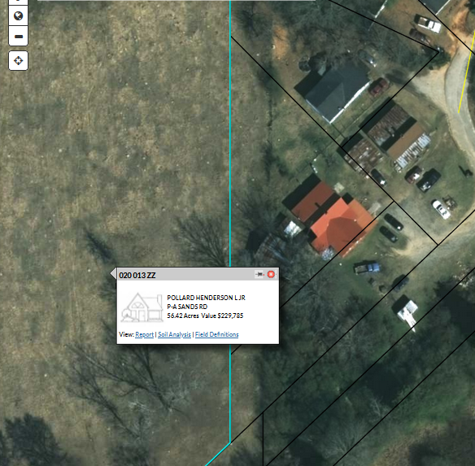

Mayor Corley pointed out that according to City Zoning Ordinance, the property, which is zoned R-1, Single-Family Residential, agriculture is an allowed use, and Mr. Pollard is allowed to raise cattle on the property. The City cannot tell a private citizen how or what they may do on their property as long as they conform with City ordinances and the law.
Mayor Corley did ask City Attorney Scott Mayfield to send a certified letter to Mr. Pollard to his mailing address in Senoia to advise him of Mr. Milner’s concerns and ask him to please move his feeding location.
Chief Polk advised he will attempt to reach Mr. Pollard via telephone as well.
- Chief of Police Report
Number of Calls 165, 110 were traffic stops/48 citations (see reports in Council folders)
Responded to Concord at the request of Pike County on a barricaded gunman call last week to provide assistance
Status of Vehicles & Mileage
Explorer 31,040 – great condition
Tahoe 152,648 – not in good shape
Crown Victoria, We have four
Balance Ford loan $31,328.90

Had a license check on February 24
McCrary Road and Hwy 18 @ Dunn Road
Had 8 cars come through on McCrary Road
Had 268 on Hwy 18 @ Dunn.
1 DUI
1 Marijuana Case
13 Traffic Citations
- Approval of Agenda/Approval of Minutes
Approval of Agenda and Minutes of previous meeting
Motion: Jennifer Riggins, Mayor Pro Tempore, Post 1
Second: Councilmember Luis J. Vazquez, Sr., Post 4
Vote: Yay 5 Nay 0
- Reports from Council and Committees and New/Old Business
Buildings, Streets and Grounds - Allison Turner
122 East Jones Street – sewage running down hill
Health Department came out – Ben Trotter & Susan Boggs
Spoke with daughter – thought it was washing machine water
Based on evidence, not washing machine water
There were other possible code violations to be addressed
Health Department will be in contact with Ms. Payne
Public Safety - Jennifer Riggins
No report
Ways & Means - Luis Vazquez
No report
Technology & Engineering - Luis Vazquez
No report

Water – Willie McDowell
Reported on meeting site visit with Joel Bowen, water superintendent.
Discussed need to replace old water meters to prevent loss.
Mayor’s Report – Joyce Corley
Had septic tank at the pavilion pumped.
Discussed problems with shared septic system between City Hall and Molena Meadows.
Pumped April 2022.
Pumped November 2022.
Was full Friday of last week.
Did actually empty when rain ended.
Couch advised what needs to be done to locate the fill lines. Cost estimate between $2,500 and $2,500.
Health Dept. has advised Molena Meadows requires a dedicated septic tank.
Broadband update:
White Plains BC equipment is in.
Will come down to $5,000 on Sands PTMP.
Motion to approve invoice to repair equipment damaged by lightning $1,575
Motion: Councilmember Allison Turner, Post 5
Second: Councilmember Luis J. Vazquez, Sr., Post 4
Vote: Yay 5 Nay 0
Motion to approve quote to order 10 antennas at $1,850 and order
Motion: Councilmember Allison Turner, Post 5
Second: Councilmember Luis J. Vazquez, Sr., Post 4
Vote: Yay 5 Nay 0
Motion to approve SLA with David Stewart
$5 per device monitoring
Dispatches within three hours Monday through Friday at flat rate of $50 per hour with monitoring – travel fee of $25
After-hour dispatch 5 p.m. to 8 a.m. $150 per hour with monitoring - $25 travel fee
Weekend dispatch $150 per hour with monitoring - $25 travel fee

- Old/Unfinished Business
None
- New Business
Appoint new signer for City Accounts
Councilmember Luis J. Vazquez, Sr., Post 4 appointed since he is ways and means.
Motion: Appoint Ways and Means Councilmember Luis J. Vazquez, Sr., to be signer on City Accounts in place of Damon Riggins and remove Damon Riggins from City Accounts.
Motion: Councilmember Allison Turner, Post 5
Second: Councilmember Willie McDowell, Jr., Post 2
Vote: Yay 4 Nay 0
Purchase paint for City Shop
Discussed painting the city shop
Decided to purchase up to $1,500 in materials to paint the building
Motion: Councilmember Allison Turner, Post 5
Second: Councilmember Luis J. Vazquez, Sr., Post 4
Vote: Yay 4 Nay 0

City Clerk reported Account opened with O’Reillys
Verifying Account with The Home Depot also applies to Griffin Home Depot
Vote: Yay 4 Nay 0

Council Adjourned
Motion: Councilmember Allison Turner, Post 5
Second: Councilmember Luis J. Vazquez, Sr., Post 4
Vote: Yay 4 Nay 0

