CITY OF MOLENA
10 SPRINGS ROAD
MOLENA, GA 30258
Joyce Corley, Mayor Jennifer Riggins, Mayor Pro Tempore, Post 1
Matthew Polk, Police Chief Willie McDowell, Jr., Post 2
Andrea Ashby, Post 3
Joel Bowen, Water Works Luis J. Vazquez, Sr. Post 4
Tina L. Lee, City Clerk Allison Turner, Post 5
L. Scott Mayfield, City Attorney
February 13, 2023
Present: | Mayor Joyce Corley, Council Member Willie McDowell, Jr., Post 2; Councilmember Luis J. Vazquez, Sr., Post 3 Council Member Andrea Ashby, Post 3; Council member Allison Turner, Post 5; City Attorney Scott Mayfield; Chief of Police, Matt Polk; City Clerk, Tina Lee
Next meeting: | March 13, 2023, 6 p.m., Molena City Hall
- Call to Order
- Pledge and Invocation
- Public Comments and Invited Guests
No Public Comments
County manager Brandon Rogers – signing of Service Delivery Agreement
Discussed cost of animal control
City Attorney Scott Mayfield advised City of Molena to let County handle all animal enforcement cases
Discussed Code enforcement IGA specific to buildings and building code enforcement
Discussed public works IGA
Signed by Joyce Corley, Mayor and witnessed by City Clerk Tina Lee.
Discussed SPLOST Bond
Need projects if want to be a part of up-front funding
County is not ready to submit and will be ready next year.
Discussed 911 cost mailer
Would like to sit down and discuss further
Discuss the use of the E911 center and how that affects Pike County, Molena, and Zebulon.
Still trying to figure out a day to meet.
- Approval of Agenda/Approval of Minutes
Approval of Agenda and Minutes of previous meeting
Motion: Councilmember Allison Turner, Post 5
Second: Councilmember Luis J. Vazquez, Sr., Post 4
Vote: Yay 5 Nay 0

- Chief of Police Report
See attached report
Number of Calls 95 (see reports in Council folders)
Status of Vehicles & Mileage
Explorer 29,232 – great condition
Tahoe 151,976 – not in good shape
Crown Victoria, We have four
Condition of vehicle
Balance Ford loan $32,105.54
  - 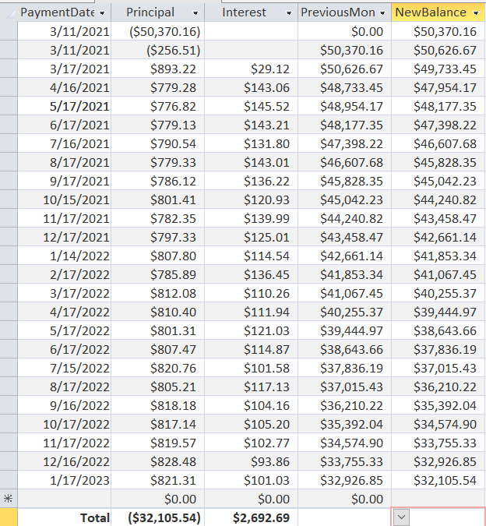
- Discussed possibly paying bi-weekly
  - Small savings over life of the loan.
  - Will begin immediately making the by-weekly payments.
- Reports from Council and Committees and New/Old Business
Buildings, Streets and Grounds - Allison Turner
No report
Public Safety - Jennifer Riggins
Not present
Ways & Means - Luis Vazquez
No report
Technology & Engineering - Luis Vazquez
Meeting with Mr. Stewart
Would like to hear how that meeting went
Water – Willie McDowell
Has arranged to visit the well sites with Joel Bowen

Mayor’s Report – Joyce Corley
Meeting with Mr. Stewart two weeks ago
He will continue to install residences on Wednesdays
Provided quote to monitor network of $225 monthly ($5 per device)
Provided price for emergency calls of $150
Provided quote for White Plains Baptist Church
$3,000 to place antenna/pole/anything else required
Motion to approve placement/installation at White Plains Baptist Church
Motion: Councilmember Luis J. Vazquez, Sr., Post 4
Second: Councilmember Willie McDowell, Jr., Post 2
Vote: Yay 5 Nay 0

Place on Sands Road to place a PTMP to reach at least 10 customers
Opens up the possibility of more clients
$5,200 to place antenna/pole/anything else required
Council decided to ask if Mr. Stewart will reduce his price to $5,000

- Old/Unfinished Business
None
- New Business
Appoint new signer for City Accounts
Councilmember Luis J. Vazquez, Sr., Post 4 appointed since he is ways and means.
Motion: Appoint Ways and Means Councilmember Luis J. Vazquez, Sr., to be signer on City Accounts in place of Damon Riggins and remove Damon Riggins from City Accounts.
Motion: Councilmember Allison Turner, Post 5
Second: Councilmember Willie McDowell, Jr., Post 2
Vote: Yay 4 Nay 0
- Roundtable
Councilmember Willie McDowell, Jr., Post 2 discussed painting City shop.
Agreed to paint the shop and set a budget for supplies
City Clerk Tina Lee advised account has been opened with O’Reilly’s in Griffin
Verifying the Home Depot account is good in Griffin as well.
Motion allow up to $1,500 for supplies to paint shop and cement for picnic tables
Motion: Councilmember Allison Turner, Post 5
Second: Councilmember Luis J. Vazquez, Sr., Post 4
Vote: Yay 4 Nay 0
- Adjournment
Motion: To adjourn
Motion: Councilmember Allison Turner, Post 5
Second: Councilmember Luis J. Vazquez, Sr., Post 4
Vote: Yay 4 Nay 0

