REGULAR MONTHLY COUNCIL MEETING AGENDA
Monday, February 13, 2023 – 6:00 PM
City Hall, Molena, Georgia
- CALL TO ORDER
Mayor Corley
- PLEDGE/INVOCATION
- PUBLIC COMMENTS AND INVITED GUESTS
  - Citizen's Comments
    - General comments – 2 minutes
  - None
- APPROVAL OF AGENDA/APPROVAL OF MINUTES
  - Minutes of previous meeting(s) were provided to Council for approval.
    - Regular meeting Monday, January 9, 2023.
- CHIEF OF POLICE REPORT
  - See attached report
  - Number of Calls 95 (see reports in Council folders)
  - Status of Vehicles & Mileage
    - Explorer
    - Tahoe
    - Crown Victoria
  - Condition of vehicle
  - Balance Ford loan $32,105.54
    - 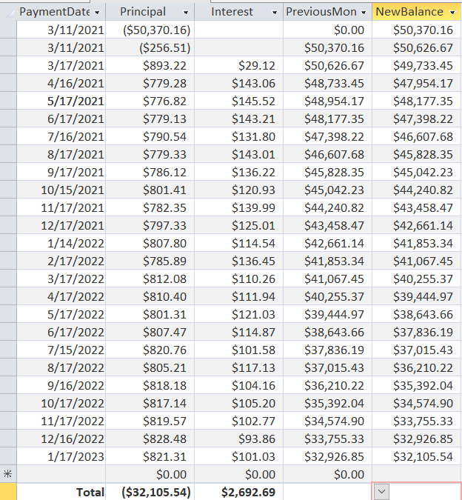

- Other business
REPORTS FROM COUNCIL AND COMMITTEES
- Buildings, Streets and Grounds - Allison Turner
- Public Safety - Jennifer Riggins
- Ways & Means - Luis Vazquez
- Technology & Engineering - Luis Vazquez
  - Meeting with Mr. Stewart (Defer to Mayor?)
- Water – Willie McDowell
MAYOR'S REPORT
- OLD/UNFINISHED BUSINESS
- New Business
  - Vote on items discussed in goals meeting
  - Appoint signer for city accounts
- EXECUTIVE SESSION
- ROUNDTABLE DISCUSSION
  - Councilmember Jennifer Riggins
  - Councilmember Willie McDowell
  - Councilmember Andrea Ashby
  - Councilmember Luis Vazquez
  - Councilmember Allison Turner
  - Mayor Joyce Corley
  - City Attorney Scott Mayfield
- NEXT REGULAR MEETING
  - Monday, March 13, 2023, 06:00 PM
- ADJOURNMENT

