Molena City Council
Location: | 10 Springs Road, Molena, GA 30258
Date: | May 08, 2023
Time: | 6:00 PM

regular monthly council meeting agenda

call to order

Mayor Joyce C. Corley

pledge/invocation

Councilmember Willie McDowell, Jr., Post 2

public comments and invited guests

Approval of previous minutes and current agenda

chief of police report

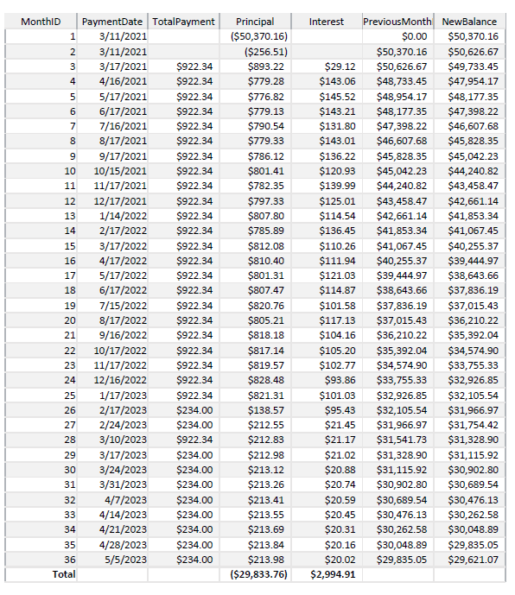
Number of Calls – 121/77 Traffic Stops (see reports in Council folders)

19 Traffic Citations between April 1 and April 30

Status of Vehicles & Mileage
    - Explorer
    - Tahoe

Balance of Ford Loan $29,621.07 (see included)

reports from council and committees

Buildings, Streets, and Grounds – Councilmember Allison Turner, Post 5

Public Safety – Jennifer Riggins, Mayor Pro Tempore, Post 1

Ways & Means – Councilmember Luis j. Vazquez, Sr., Post 4

Technology & engineering – Councilmember Luis J. Vazquez, Sr., Post 4

Potential new software

White Plains Baptist Church Installation is almost complete

Water – Councilmember Willie McDowell, Jr., Post 2

Discuss current water issues

Discuss past due water bills scheduled for cutoff if any

221 E Jones Street is still disconnected

mayor’s report

Potential City Hall Rental

old/unfinished business

Sands Road PTMP

Continued discussion re Septic System

City Hall Rental

Raise amount of deposit at pavilion

new bus

City Clerk is requesting purchase of Ampstun financial software to replace the current software.

executive session

roundtable discussion

adjournment

Next regular meeting will be Monday, June 12, 2023, 06:00 PM

