Molena City Council
Location: | 10 Springs Road, Molena, GA 30258
Date: | June 12, 2023
Time: | 6:00 PM

regular monthly council meeting agenda

call to order

Mayor Joyce C. Corley

pledge/invocation

Councilmember Willie McDowell, Jr., Post 2

public comments and invited guests

Approval of previous minutes and current agenda

chief of police report

Number of Calls – May 1-May 31 121/ 79 Traffic Stops (see reports in Council folders)

19 Traffic Citations between May 1 and May 31

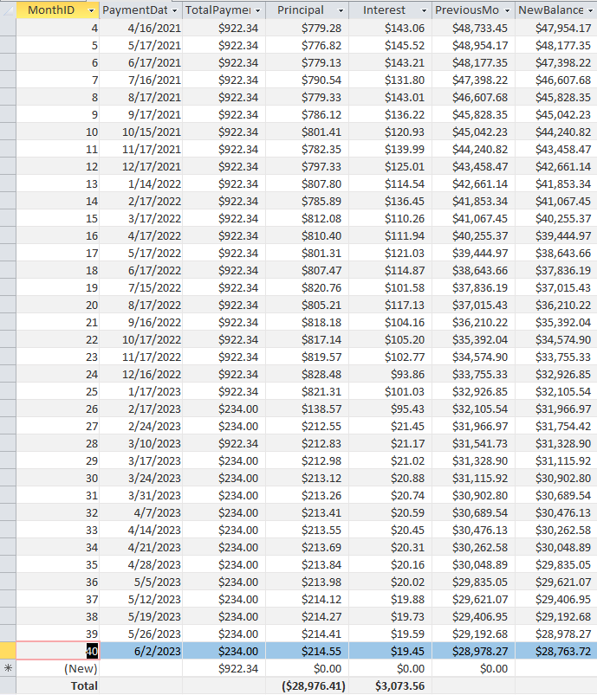
Status of Vehicles & Mileage
    - Explorer
    - Tahoe

Balance of Ford Loan $28,763.72 (6/9/23 payment not reflected)

reports from council and committees

Buildings, Streets, and Grounds – Councilmember Allison Turner, Post 5

Public Safety – Jennifer Riggins, Mayor Pro Tempore, Post 1

Ways & Means – Councilmember Luis j. Vazquez, Sr., Post 4

Technology & engineering – Councilmember Luis J. Vazquez, Sr., Post 4

Water – Councilmember Willie McDowell, Jr., Post 2

Katie Chapman – Grant writer

mayor’s report

Meeting with Roger Lumsden

old/unfinished business

Purchase of Ampstun Software

Vote to proceed with purchase

Vote to amend budget to accommodate purchase

City Hall Rental – tabled until later

Raise amount of deposit at pavilion – tabled until later

new busINess

Purchase Dodge Charger for Molena Police Department

Vote to proceed with purchase

Vote to amend budget to accommodate purchase / seek loan for purchase and amend budget to accommodate payments

Bonus for City Clerk

Vote to approve

Approve purchase of mulch for city park.

See quotes

executive session

roundtable discussion

adjournment

Next regular meeting will be Monday, July 10, 2023, 06:00 PM

