REGULAR MONTHLY COUNCIL MEETING AGENDA
Monday, January 9, 2023 – 6:00 PM
City Hall, Molena, Georgia
- CALL TO ORDER
Mayor Corley
- PLEDGE/INVOCATION
- SWEARING IN OF COUNCILMEMBER
- Reappoint City Attorney, Chief of Police, City clerk
- PUBLIC COMMENTS AND INVITED GUESTS
  - Citizen's Comments
    - General comments – 2 minutes
  - Invited guest –
    - Matt Marston – Short-term rental 75 Springs Road
    - Randy Davis – Plans to subdivide Main Street lot
- APPROVAL OF AGENDA/APPROVAL OF MINUTES
  - Minutes of previous meeting(s) were provided to Council for approval.
    - Regular meeting Monday, December 12, 2022.
    - Minutes emergency called meeting
  - Voted to add publishing of qualifying fees
- CHIEF OF POLICE REPORT
  - See attached report
  - Number of Calls &
  - Status of Vehicles & Mileage
    - Explorer
    - Tahoe
    - Crown Victoria
  - Condition of vehicle
  - Balance Ford loan $32,926.85
    - 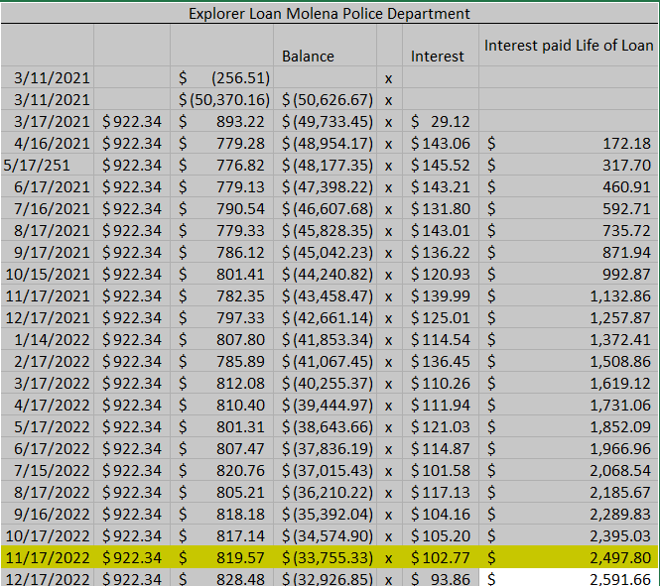
- Other business
REPORTS FROM COUNCIL AND COMMITTEES
- Buildings, Streets and Grounds - Allison Turner
- Public Safety - Damon Riggins
- Ways & Means - Luis Vazquez
- Technology & Engineering - Luis Vazquez
- Water - Jennifer Riggins
MAYOR'S REPORT
- OLD/UNFINISHED BUSINESS
- New Business
  - New Council Committee Assignments
  - Discuss possibly having County handle 2023 Property Tax and Property Taxes going forward instead of Harris Local Government. Fee would be 2.5% of tax revenue.
  - Set date for goal planning session
  - Note: 2023 Holidays
    - These are the days the City Offices will be closed in 2023.
    - October 9 is the date of the October City Council meeting.
- New Year’s Day: Sunday, January 1 (Observed Monday, January 2)
- Martin Luther King Jr Day: Monday, January 16
- Presidents’ Day: Monday, February 20
- Memorial Day: Monday, May 29
- Independence Day: Tuesday, July 4
- Labor Day: Monday, September 4
- Columbus Day: Monday, October 9
- Veterans’ Day: Saturday, November 11 (Observed Friday, November 10)
- Thanksgiving: Thursday, November 23
- Black Friday: Friday, November 24
- Christmas: Monday, December 25
- EXECUTIVE SESSION
- ROUNDTABLE DISCUSSION
  - Councilmember Jennifer Riggins
  - Councilmember Damon Riggins
  - Councilmember Andrea Ashby
  - Councilmember Luis Vazquez
  - Councilmember Allison Turner
  - Mayor Joyce Corley
  - City Attorney Scott Mayfield
- NEXT REGULAR MEETING
  - Monday, February 13, 2023, 06:00 PM
- ADJOURNMENT

